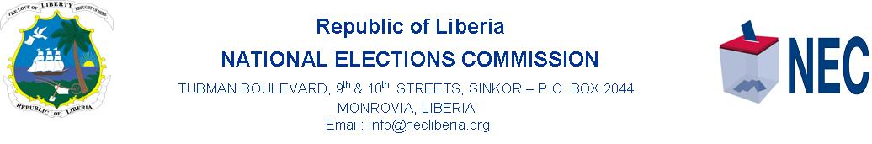
PRESS STATEMENT
NEC Submits By-elections Budget to Legislature

MONROVIA, 28 September 2020……. The National Elections Commission, (NEC) says it has submitted a joint budget to the 54th National Legislature for approval for the conduct of the By-elections in District numbers 9 and 2 in Montserrado and Sinoe Counties, respectively.
A statement from the NEC today, Monday 28 September 2020 says the joint by-elections budget is Three Hundred Ninety-Eight Thousand, Four Hundred Ninety-Seven dollars and thirty-two cents.
The NEC statement said of this total, Two Hundred Twenty-Nine thousand, Two Hundred Thirty-one United States dollars and Ninety-seven cents will go for the conduct of the district number 9 by-election in Montserrado County.
According to the NEC statement, One Hundred Sixty-Ninety thousand and Two Hundred Sixty-Five United States dollars and thirty-five cents would be used to conduct the district number 2 by-election in Sinoe County.
The National Elections Commission has set December 8, 2020, same date for the SSE and Referendum, for the conduct of the two by-elections.
Meanwhile, the Candidate Nomination Exercise for the conduct of the by-elections begins on October 5, 2020 and runs until 16 October 2020 at the Headquarters of the National Elections Commission in Sinkor, Monrovia.

